**-SonarQube Installation Steps:**

You can follow below steps in order to installing Sonar Java Code Analysis Tool. Which will dramatically imporve code quality.

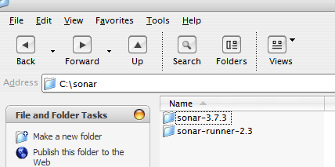

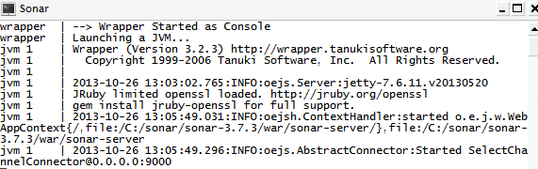

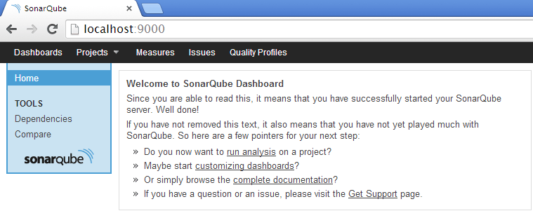

Now, You can see sonar server is started

1. Copy and unzip sonar.zip and sonar-runner.zip
2. Start the Sonar server using the script available in SONAR_HOME\bin\windows-x86-32\StartSonar.bat (OS dependent)
3. After starting the server you can browse to http://localhost:9000

**Creating Project & Analysing Using Sonar**

For setting environment variable, you can do following steps

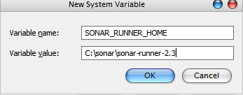

Also append C:\sonar\sonar-runner-2.3\bin to Path.

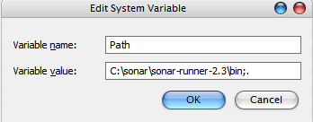

Note

CREATE USER 'sonar' IDENTIFIED BY 'sonar';

GRANT ALL ON sonar.* TO 'sonar'@'%' IDENTIFIED BY 'sonar';

GRANT ALL ON sonar.* TO 'sonar'@'localhost' IDENTIFIED BY 'sonar';

FLUSH PRIVILEGES;

1. In this tutorial, we are using h2 database which is default configured with SonarQube, You can also use any of these databases (mysql,plsql,oracle etc),  
   For example, If you are using mysql, just execute the following sql script
2. Edit sonar.properties in  \conf\sonar.properties.

just comment Connection url for h2 and uncomment Connection url for mysql

sonar.jdbc.url:jdbc:h2:tcp://localhost:9092/sonar

sonar.jdbc.url: jdbc:mysql://localhost:3306/sonar?useUnicode=true&characterEncoding=utf8&rewriteBatchedStatements=true

# Required metadata

sonar.projectKey=java-sonar-runner-simple

sonar.projectName=Simple Java project analyzed with the SonarQube Runner

sonar.projectVersion=1.0

# Comma-separated paths to directories with sources (required)

sonar.sources=src

# Language

sonar.language=java

# Encoding of the source files

sonar.sourceEncoding=UTF-8

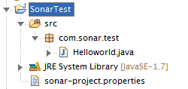

1. Set a new environment variable as SONAR_RUNNER_HOME. And its value should be C:\sonar\sonar-runner-2.3 (unzipped path of sonar-runner.zip)
   1. From the Desktop, right click on My Computer and click Properties.
   2. Click Advanced System Settings link in the left column.
   3. In the System Properties window click the Environment Variables button.
   4. Inside System variable, click on New Button
2. Create a new Java Project and add below sonar-project.properties file into the root of the project folder (see below project strcuture)

sonar-project.properties

1. Using the terminal go the project home and run the command sonar-runner (Sonar Server must be started)
2. After the success run browse the web  http://localhost:9000 where you can see the report related to the project

